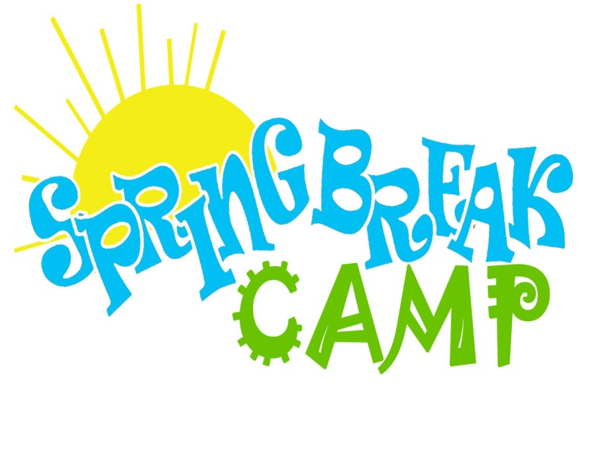

Full day & Half day options available

**Morning Session: 9:00am-12:00pm (snack included)**

**Afternoon Session: 1:00pm-4:00pm (snack included)**

* $40 ½ Day |$175 ½ Day Week
* $70 Full Day | $300 Full Day Week
* $5 sibling discount per session
* 3-4 year olds may only do **one** session per day (morning or afternoon)

**March 18th-22nd**

Come join the fun here at NVG. Campers will enjoy a week of structured gymnastics lessons, group games, supervised open gym, sports creations and snacks! You don’t want to miss out!

**Must Pre-Register! Space is limited**



Full day & Half day options available

**Morning Session: 9:00am-12:00pm (snack included)**

**Afternoon Session: 1:00pm-4:00pm (snack included)**

* $40 ½ Day |$175 ½ Day Week
* $70 Full Day | $300 Full Day Week
* $5 sibling discount per session
* 3-4 year olds may only do **one** session per day (morning or afternoon)

**March 18th-22nd**

Come join the fun here at NVG. Campers will enjoy a week of structured gymnastics lessons, group games, supervised open gym, sports creations and snacks! You don’t want to miss out!

**Must Pre-Register! Space is limited**